
a
Company
Logotype

Cone Beam Computed Tomography- Report



Porur Dental X-rays & CBCT

Patient Name : Mr. Ramachandran | Date of Report : 14.04.2024
Age/ Gender : 69 years/ Male | Region of Interest : CBCT Sectional Maxilla
Referring doctor: Dr. Sandhya Boominathan | Indication : Implant assessment
Clinical Notes: Nil
PATIENT INFORMATION

CBCT- Sectional Maxilla provided
CBCT – IMAGE DETAILS

RADIOGRAPHIC INTERPRETATION

- Hyperdense crown structure in relation to: 24, 25, 26.
- The tooth 24 is present with hyperdense restorative material within the crown, extending upto the apical third of the root. The tooth 26 is present with hyperdense restorative material only within the palatal root canal.
 | 24 region | 25 region | 26 region
Sub-Crestal (in mm) | 8.34 | 7.78 | 13.26
Mid- Crestal (in mm) | 9.21 | 9.27 | 13.26
Distance between the alveolar ridge and floor of the maxillary sinus (in mm) | 16.52 | 7.41 | 7.33
IMPLANT ASSESSMENT

RADIOGRAPHIC IMPRESSION

- Root canal treated teeth: 24, 26.
- Crown in relation to 24, 25, 26

Kindly correlate with clinical findings


IMAGES FOR REFERENCE

RECONSTRUCTED PANORAMIC VIEW

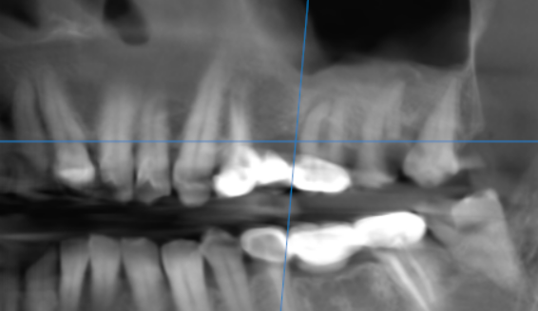

3-DIMENSIONAL VIEW

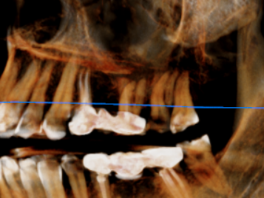

CROSS SECTIONAL VIEW

24 region | 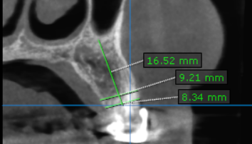
25 region | 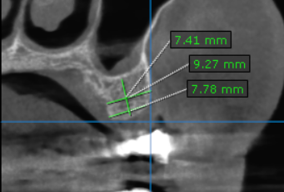
26 region | 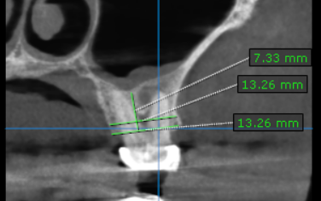

**** End of report ****

